DISCOVERING YOUR IKIGAI

Ikigai is a Japanese concept roughly translated into “reason for being”. It describes the experience of feeling that sense of aliveness and purpose. It’s at the intersection of four things: what you love doing; your zone of genius; what the world needs; what the world will pay you for (see diagram below).
https://www.bbc.com/worklife/article/20170807-ikigai-a-japanese-concept-to-improve-work-and-life

You can read more about it through the link below or in various books including in Ikigai: The Japanese secret to a long and happy life by Héctor García and Francesc Miralles.

In the meantime, you can try the exercise below.

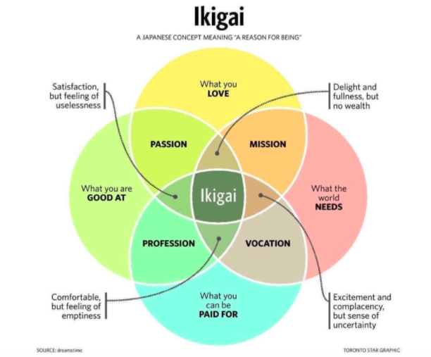

Take 30-60 mins in to contemplate:
Q1) What do you love doing?
List things that have taken you into flow states, particularly over the past 2 or 3 years; e.g. for me it was deep transformational conversations where being together was more important than thinking or doing together, as well as writing to share experience and insights.
Q2) What would you say is your zone of genius?
Take stock of:
- Your zone of competence: things you can do
- Your zone of excellence: things you're really good at
- Your zone of genius: things you're exceptional at. This is something you're often blind to and think that everyone else can do or isn't that big a deal e.g. empathy and holding space for others to drop beneath surface thinking into their essence and power – drawing out their creative ideas and wisdom
(c.f. Gay Hendricks’ work on this and his book The Big Leap)
Q3) What do you feel is missing in the world right now that could make a big difference?
Q4) Who is doing paid work that captures the elements you've identified above?
- What does that tell you about what or how you might like to work?

Q5) What limiting beliefs came up for you in any of the sections? Write down as many as you can.

Bonus exercise

What is your vision? (How could the world look better in the future?)

What is your mission (What might you do in your lifetime to contribute to this vision?)

What are your values? (Attitudes that are connected to your vision and mission that you can live every day)

What is your next step(s)?

